

**<<YOGA CENTER>>**

**Software Requirement Specification**

– HoChiMinh, May 2023 –

**Table of Contents**

I. Overview 3

1. Introduction 3

2. System Functions 4

II. Functional Requirements 7

1. Register 7

2. Login 8

3. Manage Account 8

4. View Home page 9

5. Enroll Course 9

6. View schedule 10

7. View profile 10

8. Manage Course 10

9 MembershipMembership. 11

10. Blog 11

11. Manage Blog 11

12. PayOrder 11

13. Data Statics(Dashboard) 12

144. Manage Bill 12

# I. Overview

## 1. Introduction

Yoga has been a popular practice for thousands of years, offering numerous physical and mental health benefits. In recent years, there has been a growing interest in yoga to improve overall well-being, reduce stress, and increase mindfulness.

However, finding and booking yoga classes can be a challenge, with limited options and inconvenient schedules. Customers who want to improve their health and fitness average spend 60 minutes a day going to yoga centers to practice on their own or find a suitable trainer who can help them get better health through professional exercises. Customers usually take 20-30 minutes to research a suitable training schedule as well as the trainer they want to accompany in their training sessions. The trainers also have a hard time keeping track of their work hours and teaching schedules. And also makes it difficult for the trainers to best support their students because of the above issues.

With the above disadvantages, we need a web to optimize the time of customers and employees when researching and choosing courses at our center.

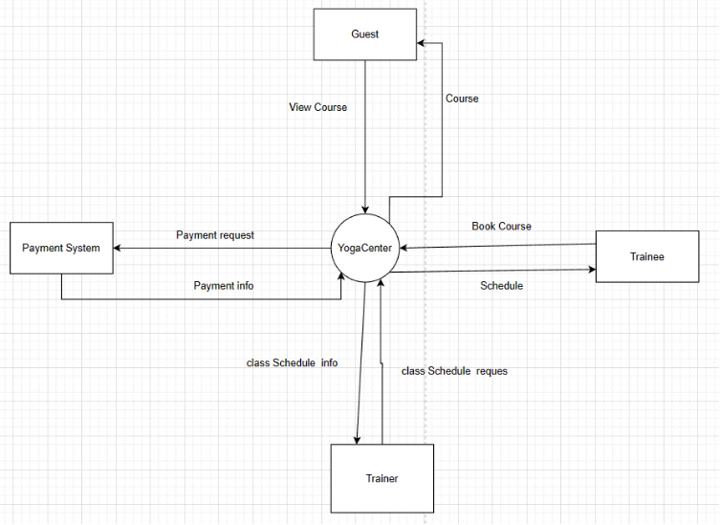

## 2. System Functions

#### a. Screen Flow

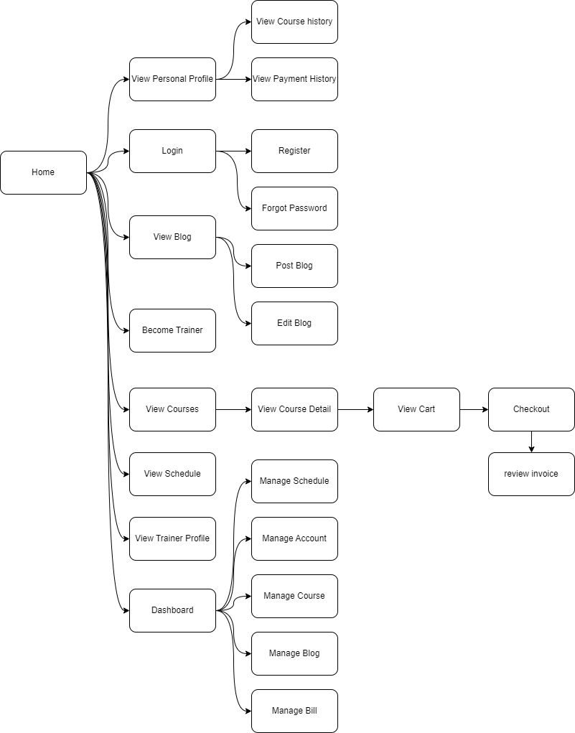

#### b. Screen Details

| **#** | **Feature** | **Screen** | **Description** |
| --- | --- | --- | --- |
| 1 | Register | Register | User can register as customer |
| 2 | Login | Login | User enter username and password to login |
| Forgot Password | User enter email to receive code for change password |
| 3 | Manage account | Manage account | Admin create a new account for staff |
| Admin update account for staff |
| Admin remove account’s staff when they quit job |
| 4 | View Home page | Home | User will go to HomePage after visiting the website |
| 5 | Enroll Course | View Course | Users can view the course list. |
| View Course Detail | Users can view course details, and have a enroll button for buying courses. |
|
| View Trainer Profile | User can view the staff profile. |
|
| View Course History | User can see all the courses which they register |
|
| 6 | View schedule | View schedule | User can see the timetable of courses which they enroll |
| 7 | View profile | View personal profile | User, staff can view and edit their personal profile |
| 8 | Manage course | Manage course | Admin can remove courses because they are out of date, Admin can add a new course, Admin can edit time, of course. |
|
| Manage Schedule | Admin can set up a timetable for trainer and trainee |
| 9 | Blog | View blog | User can see an introduction about the course, news |
| 10 | Manage Blog | Manage Blog | Staff post new news |
| Admin remove news out of date |
| Admin update news |
| 11 | PayOrder | Checkout | User payment course |
|
| Review invoice | Show info payment |
| Issues an invoice |
| Send invoice to email |
| 12 | Data Statistics | DashBoard | Aggregate and display data in the form of graphs |
| 13 | Manage Bill | Manage Bill | Admin can view all invoice data |
| 14 | Manage Membership | Manage Membership | Admin add new membership |
| Admin can view all membership list |
| Admin can update membership |

#### c. User Authorization

| **#** | **Screen** | **Guest** | **Trainee** | **Trainer** | **Admin** |
| --- | --- | --- | --- | --- | --- |
|  | Register | X |  |  |  |
|  | Log in | X | X | X | X |
|  | Forgot Password |  | X | X |  |
|  | Manage account |  |  |  | X |
|  | Manage schedule |  |  |  | X |
|  | Home | X | X | X | X |
|  | View course detail | X | X | X |  |
|  | View Courses | X | X | X |  |
|  | Add wishlist course |  | X |  |  |
|  | View Trainer Profile | X | X | X |  |
|  | View Schedule |  | X | X |  |
|  | View course History |  | X |  |  |
|  | View schedule |  | X | X |  |
|  | View personal profile |  | X | X |  |
|  | Manage course |  |  |  | X |
|  | View Blog | X | X | X |  |
|  | Post Blog |  | X | X |  |
|  | Manage Blog |  |  |  | X |
|  | Membership Page | X | X |  |  |
|  | Checkout Membership |  | X |  |  |
|  | Checkout Course |  | X |  |  |
|  | Review invoice |  | X |  |  |
|  | View Payment History |  | X |  |  |
|  | Become Trainer |  | X |  |  |
|  | Dashboard |  |  |  | X |
|  | Manage Bill |  |  |  | X |

#### d. Non-Functional Requirements

| **#** | **Feature** | **System Function** | **Description** |
| --- | --- | --- | --- |
| 1 | User Authorization | Authorization | An authorization mechanism should be implemented in the system to specify the role of the logged-in user and their authorized page links. This includes building the displayed menu items in the front-end and preventing unauthorized access by directly entering links |
| 2 | Easy to use | Provide smooth flow, friendly UI | All users, including guests, customers, staff, and admins, should be able to use the system without having to think about how functions work or what will happen if they click a button. This can be achieved by building a comprehensive navigation flow and designing a user-friendly user interface (UI). |

## 

# II. Functional Requirements

## Register

* **Function trigger:** 
  + This function will be triggered when the button is clicked on the login page.
* **Function description:** 
  + Guest roles will have access to this function.
  + This function is for creating a new user account.
* **Function detail:**
  + Pressing the Register button after entering all of the fields correctly, the user can create a new account with the corresponding information in the database.
  + Entering any field wrong will show a pop-up that says that the input is invalid and requires the user to try again.

## Login

1. **Login**

* Function trigger: This function will be triggered by a button on the Home Page
* Function description:
  + Trainee, trainer, and admin will use this function to access their account
  + This function will help trainee and trainer have an account to enroll the course, check the timetable, payment for the course
  + This function will help the admin have an account to manage the course, manage a blog, manage bill, manage account and dashboard.
  + This function helps the system authenticate users.
* Function detail:
  + Entering a valid username and password, the user will have access to the system. If not, they won’t be able to access it.
  + In case of forgetting the password, the user will click on the hyperlink forgot password to forward to the forgot password screen.
  + When the user can only interact with the website with some basic function, they can click on the hyperlink sign up here to create a new account.

1. **Forgot password**

* Function trigger: This function will be triggered when the user clicks the hyperlink forgot password on the Login page
* Function description:
  + Trainee, trainer, and admin will use this function
  + This function will help trainees, trainers, and admin users generate new passwords by confirm OTP through email.
* Function detail:
  + System will ask some questions about authentication that the user has preset in case they do not remember the password when creating an account.
  + Enter a new password and confirm the new password
  + Login again with a new password.

## Manage Account

* Function trigger: This feature will be triggered when the admin clicks on the hyperlink “Manage Account”
* Function description:
  + Only the admin can access this feature.
  + This function allows the admin to view all users and their information in the system.
  + This function also gives admin permission to create a new trainer account
* Function detail:
  + The admin can see a list of all of the users paginated sorted by id in default.
  + The admin can search by name
  + The list is a sorting table by id, full name, role, or status
  + The admin can ban the user if needed

## View Home page

* Function trigger: The page shows up when users access the web application.
* Function description:
  + All roles in the system will access this function.
  + Show a link/button to access other functions of the project.
  + Display information about the website, membership, and contact.
* Function detail:
  + Components to link to other functions like product purchase, and login….
  + Display some information about the website.

## Enroll Course

1. **View courses**

* Function trigger: This function will be triggered by a button on the Home Page
* Function description:
  + Trainee and guest can use this function
  + This function will show all courses of the Yoga Center
  + Help guest and trainee can assessments so they can choose the right course for them
* Function detail:
  + Show course list with thumbnail, title.
  + Filter courses by each category corresponding to or by the updated date of the courses.
  + Search for a product by inputting the name in the search bar.

1. **View course detail**

* Function trigger: This function will be triggered by a button on the View Course
* Function description:
  + Trainee and guest can use this function
  + This function will show information detail of each course
  + Help guest and trainee can assessments so they can choose the right course for them
* Function detail:
  + Show course information with thumbnail, title, feedback, course description and “Enroll” button.
  + Some related courses.

1. **View course history**

* Function trigger: This function will be triggered when clicking the button “view course history on the personal profile page.
* Function description:
  + Trainee can use this function
  + This function can show the history of courses they attended after paid
* Function detail:
  + show a list of paid courses including thumbnail, category, title, and registration date

1. **View trainer profile**

* Function trigger: This function will be triggered by a button on the View Course
* Function description:
  + Trainee and guest can use this function
  + This function will show trainer information about each course
* Function detail:
  + Show information about the trainer's name, qualifications, teaching experience, previous student evaluations and “Back” button.

## View schedule

* Function trigger: this function will be triggered when the user clicks on” Time table”
* Function description:
  + Trainees and trainers can view class schedules.
  + This function shows the information about category, class, date, and time.
* Function detail:
  + If accessed from the trainee's direction, this function will allow the user to view the trainee’s timetable, trainee list, and trainer information.
  + If accessed from the trainer’s direction, this function will allow the user to view the instructor’s class schedule, trainee list, and trainee information.

## View profile

* Function trigger:
  + this feature will be triggered when the user clicks on “View personal profile”
* Function description:
  + Trainer and trainee can access this feature
  + This feature will show the profile from which the user wants to view information
  + This feature will edit the profile which the user wants to change their information
* Function detail:
  + This feature will display the information about people who click on it.
  + This feature enables users to edit their information when clicking on it.

1. **Membership**
   1. **Buy membership**

* Function trigger: this feature will be triggered when the user clicks on “Buy Membership”
* Function description:
  + Trainee can access this feature
  + Account can upgrade their membership tier to a higher level
* Function detail:
  + This feature will display the information about people who click on it.
  + This feature enables users to edit their information when clicking on it.
  1. **View membership**
* Function trigger: this feature will be triggered when the user clicks on “View My Membership”
* Function description:
  + Trainee can access this feature
  + This feature will show the current membership of the user.
* Function detail:
  + This feature will display information about current membership.

## Manage Course

* 1. **Manage Course**
* Function trigger: function will be triggered when the admin clicks on “Manage Course”
* Function description:
  + Only the admin can access this feature.
  + This function allows the admin to view, add new courses, delete courses, and set course information.
* Function detail:
  + This function helps the account in the system to enjoy the privileges when becoming a member.
  1. **Manage Schedule**
* Function trigger: function will be triggered when the admin clicks on “Manage Schedule”
* Function description:
  + Admin can use this function.
  + Admin can arrange timetables for trainer and trainee.
* Function detail:
  + This function allows the admin to add class schedules based on subjects.
  + This function allows the admin to edit schedules if there is an unexpected situation.

## Blog

* Function trigger:
  + This feature will be triggered when the user clicks on “Blog”
* Function description:
  + Guest, trainee, and the trainer will access this feature when they want to know more things about Yoga
  + User when login with their account that can post blog, edit blog and remove blog
* Function Detail:
  + This feature help user has a point of view about something in everyday life of Yoga.

## Manage Blog

* Function trigger: this function has 2 screen features.
  + Blog Analysis: This feature will be triggered when admin clicks on “Blog Analysis”
  + Manage Blog: this feature will be triggered when the admin clicks on “Manage Blog”
* Function description:
  + Trainer and admin can access this feature
  + Trainer can post a blog, news when using this feature
  + Admin can update blog, news, also remove the blog, news out of date when using this feature
* Function detail:
  + Trainer can share their knowledge and experience, they also can use Blog to make their own diary pages.
  + Admin can update and remove the content in the Blog page if needed

## PayOrderr

## **Checkout**

* Function trigger: This function will be triggered by clicking the“Checkout” button on the “Check out” page.
* Function description:
  + Only trainees can access this function.
* Function detail:
  + Request trainees to choose a payment method.
  + Clicking the “Confirm” button to process and buy the product.
  + After clicking the “Confirm” button, a popup appears.
  1. **Review invoice**
* Function trigger:
  + This feature will be triggered when the payment is complete.
* Function description:
  + Users can view the transaction history when they complete payment.
* Function detail:
  + This feature is used to statistics the invoice for which users have paid.

## Data Statics(Dashboard)

* Function trigger:
  + This function will be triggered hyperlink “Dashboard” on the navigation bar at the left or top of the home
* Function description:
  + Only admin can access this feature
  + This function will aggregate and display data in the form of graphs
* Function detail:
  + This function will take data from the database including account data, payment data, course data, and Blog data. After that aggregate data and display:
    - Account data: Shows the total number of accounts
    - Payment data: shows the total number of invoices
    - Course data: shows the category of courses
    - Blog data: Shows the total number of blogs posted

## Manage Bill

* Function trigger: this feature will be triggered when the admin clicks on “Manage Bill”
* Function description:
  + Only the admin can access this feature
  + This feature will show all information about invoice data.
* Function detail:
  + This feature is used to statistics the transactions that users have made in the feature “Payment”